Wesley Pang  Managing Counsel  Hong Kong International Arbitration Centre | 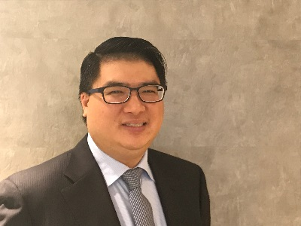

Wesley Pang is Managing Counsel of the Hong Kong International Arbitration Centre. He was formerly a Senior Associate at Shearman & Sterling LLP where he worked in the firm’s New York office, from 2008-2010, as a member of the Litigation Group, and as a member of the International Arbitration Group in Paris and London from 2010-2017. His practice focused on cross-border litigation and government regulatory investigations, as well as commercial and investor-State arbitrations, in which he advised and represented private and sovereign clients. He has served as a Co-Vice Chair of the International Investment & Development Committee of the ABA Section of International Law (2016-2017), and holds a JD from Columbia University School of Law, as well as an LLB and BSc from King’s College London. He is admitted to practice law in New York.

